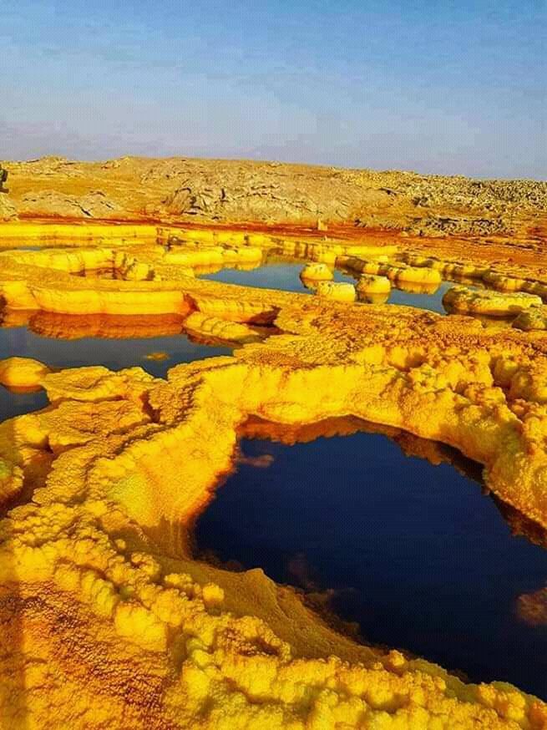
Danakil Depression Tours
No of Day/night: 03Days & 02 Nights
Mode of transportation: Car and Flight
Day 01: Fly Addis Ababa to Semera and Drive to Hamedella
This day after breakfast you will take to airport your flight to Semera. You will meet our team upon arrival and drive to Hamedella visiting beautiful landscape of solidified lava, rock, sand and occasional palm lined oasis after you pass several small hamlets start visiting Hamadella village total population of more than 500 people to see the life style of the local Afar people. Finally, precede to Salt Lake Asale a huge salty lake where you will swim in a natural pool while enjoying sunset reflections of the salty ground. Overnight camping at Hamedella
Day 02: Visit Dallol Then Drive to Erta Ale
In the Morning tour Drive to Ragad (Asebo), the place where the localities are mining salt. Look the activity of breaking the salt from the ground, cutting in to rectangular pieces and loading on camels. You drive ahead to Dallol and visit the difference landscape formed by volcanic activity (125 meter below sea level, one of the lowest and hottest places in the world) colorful salts mining and different terrestrial places formed by volcanic activity like bubbling oily lake creates a different experience of your trip. Then we back to hamadella for lunch then proceed to Ertale. We spend the night watching the dramatic action of the boiling lava. Ertale ranks one of the most alluring and physically challenging natural attractions anywhere in Ethiopia. It is a shield volcano with a base diameter of 30 km and 1km square caldera at its summit. Ertale contains the world’s only permanent lava lake. Ertale is 613 meters, with a lava lake, one of only five in the world, at the summit. It is notable for being the longest existing lava lake, present since the early years of the twentieth century. Overnight camping at Ertale
Day 03: Drive Ertale - Lake Afdera - Semera
After early Breakfast we will drive to Afdera it is used for salt extraction. It is named after the saline Lake Afdera, located in the southern part of the Afar Depression. It is a major source of salt extraction in Ethiopia, where the Lake water is pumped to saltpans for solar evaporation. After lunch we will continue the trip to Semera to take your flight to Addis Ababa and end of tour.

